**Probability and Statistics**

**Lab-7**

**Rajapaksha AGS**

**IT24100800**

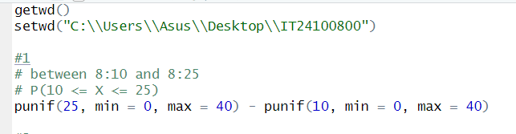**Exercise**

1. 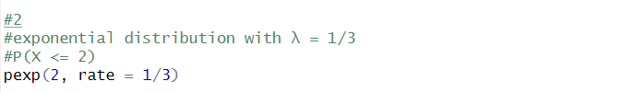

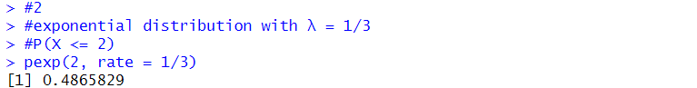

1. 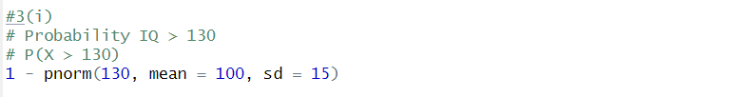**I)**

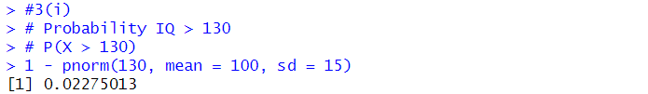

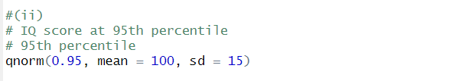**ii)**

